UPLOAD IMAGE TO IBM CONTAINER REGISTRY

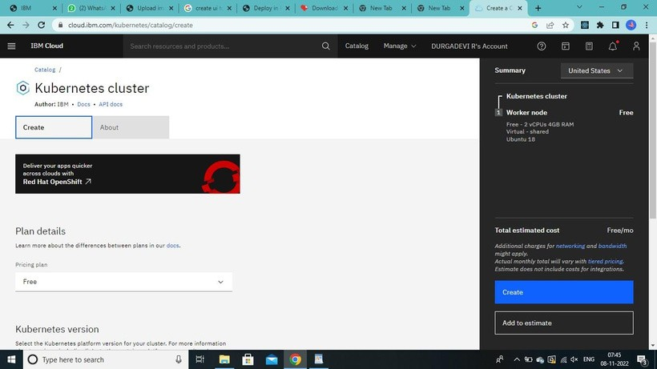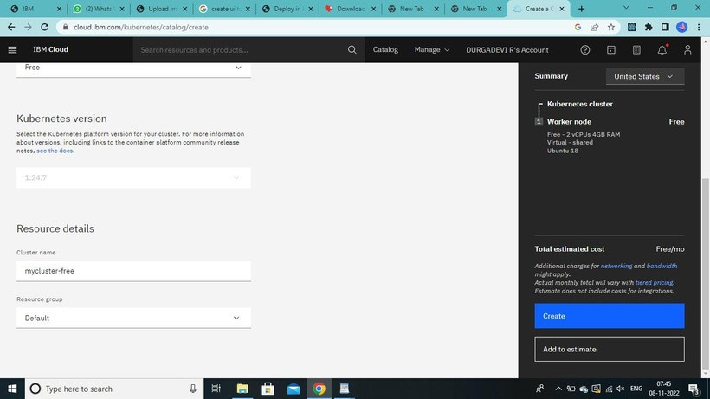

TEAM NO - **PNT2022TMID28040**

PROJECT NAME - Nutrition Assistance Application

